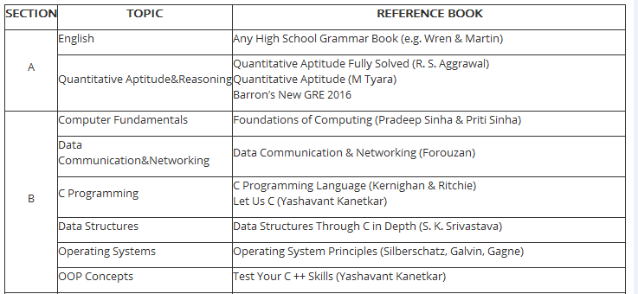Computing Fundamentals  
Evolution of Computers   
Computer Generations  
Computer Organisation  
Primary and Secondary Storage  
Input and Output Devices  
Operating System  
File Organisation  
Data Communications and Computer Networking  
  
**Fundamentals Of Programming**  
Numerical Systems  
Binary Arithmetic  
Algorithms  
Flowcharts  
Arrays - single and multidimensional  
File Orgranisations  
  
**C Programming**  
Introductory Concepts  
C Fundamentals  
Operator and Expressions   
Data Input and Output  
Operator and Expressions   
Statements (control, conditional, looping)  
Functions  
Arrays  
Pointers  
Structures and Unions   
Trees  
Stack  
Queues  
Linked Lists  
  
**Object Oriented Programming**  
Classes  
Objects  
Inheritance  
Polymorphism  
Abstract Classes  
Reusability